**IOT BASED SMART WATER**

**SUPPLY MANAGEMENT SYSTEM**

**A Project Report**

**ABSTRACT**

Water supply management system needs data regarding water storage present in Dam. Satisfying the increasing demand for water supply has been major challenge for many countries around the world. Water is one of the major requirements for human survival, conservation and management of the water resources must be given most importance. The system can measure the water level and give measurement report to the central office. This system use sensors to measure the water level of Dam and updates are provided to Corporation on daily basis. Supply of water to the particular area according to the water level in the dam, and it will be informing to the customer about water level and the time period of water supply using GSM message service. Next part contains Water meter which monitors water usage and calculate appropriate bill according to usage. It provides facility of online bill payment system.

**Keywords:** Internet of Things (IOT), Water, Wireless, GSM, Short message service (SMS), Smart aqua meter (SAM).

**INTRODUCTION**

In some water-related field such as pre-flood warning system, irrigation system, electricity powerhouse, and research, water level information is a very important issue. Usually, water level measurement was done manually, however this can be not effective due to some difficulties like problem to reach the measurement site, human error, etc. Some automatic water level measurement systems have been made using mechanical sensors such as resistive sensor, capacitive sensor, or magnetic sensor, but these sensors have to do direct contact with water that makes their life span shorter because of corrosion [1].On the other hand, this system uses ultrasonic sensor that can measure the water level without direct contact with water, which makes its life span longer.

According to the World Bank report released in 2014, urban water supply in India is faced with severe challenges including distribution inefficiency leading to higher operational costs with only 20% of the connections being metered, and in most cities about 40% water supply not resulting in any revenue. Hence, the traditional water metering system employed in India needs both infrastructural improvements and a smart flow metering approach. The manual examination of water meters for billing purposes is prone to human error and manipulation. Many of the meters are placed in inaccessible locations. Apartments and commercial complexes use a common water meter and the bill amount is shared equally irrespective of an individual’s usage, providing little incentive for residents to conserve water. The water meter readings are manually fed into a computer to provide the bill, a method that is again prone to human error.

Smart water systems can serve as alternatives to overcome the shortcomings of manual metering systems. They are wireless sensor networks: water meters installed in

thousands of households collect periodic measurements that are reported in real-time over a wireless network to a central database.

This system will update water level related notifications to web servers using internet, which means that there is no need to come directly to the measurement site. Water supply management will be done according to water level present in Dam.

This system sends the data to the central office using web server for database maintenance. The data base is secured by providing a password protected access. The user will be notified to pay the bill according to the water usage. The incoming water is measured in volumetric rate like litres per minute. The volume of water is measured with a flow sensor interfaced to arduino.

**SYSTEM DESIGN**

**System View:**

This system uses arduino, ultrasonic sensor, water flow sensor and GSM module as the main part. The system can measure the water level and give measurement to central office.

1. **Arduino:**

Arduino is a computer hardware and software company, project, and user community that designs and manufactures microcontroller kits for building digital devices and interactive objects that can sense and control objects in the physical world.

These systems provide sets of digital and analog input/output (I/O) pins that may be interfaced to various expansion boards ("shields") and other circuits.

**b. Rotobotix Water Flow Sensor YF-S201:**

This sensor sits in line with your water line and contains a pinwheel sensor to measure how much li

quid has moved through it. There's an integrated magnetic Hall Effect sensor that outputs an electrical pulse with every revolution. The hall effect sensor is sealed from the water pipe and allows the sensor to stay safe and dry. The sensor comes with three wires: red (5-24VDC power), black (ground) and yellow (Hall effect pulse output). By counting the pulses from the output of the sensor, you can easily calculate water flow. Each pulse is approximately 2.25 milliliters.

**c. GSM module:**

Sim800 GSM/GPRS USB Modem, Featuring an industry-standard interface, the SIM800 delivers GSM/GPRS 900/1800MHz performance for SMS, Data, and Audio in a small form factor and with low power consumption.

**d. Ultrasonic sensor:**

The ultrasonic sensor has a transmitter and receiver. It detects the object’s distance by transmittting ultrasonic wave for200 μs and then detect the reflection/echo wave. The time used by the wave from transmission until reflected back and received by the receiver is the key to determine object’s distance.

**FUNCTIONAL DESCRIPTION**

**User Side module:**

Once the user side module starts up, all the peripherals are initialized. The ardunio checks for water flow if water flow is detected then one more check will be performed by the ardunio if the customer has paid the trailing months bill and only if the bill has been paid the ardunio opens the valve and starts recording the quantity water flow; after completion of 30 days the data will be sent to the data-centre/ central office, this process will be in infinite loop.

Formula to calculate water flow:

Flow Rate (L/min) = Pulse frequency (Hz) / 7.5.

Flow Rate (Litres/hour) = (Pulse frequency x 60 min) / 7.5Q

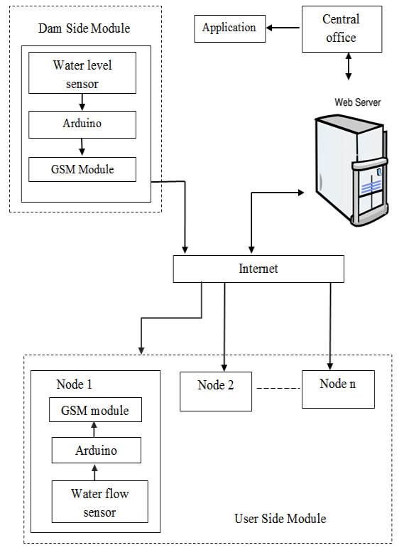

Figure 1: System architecture Diagram

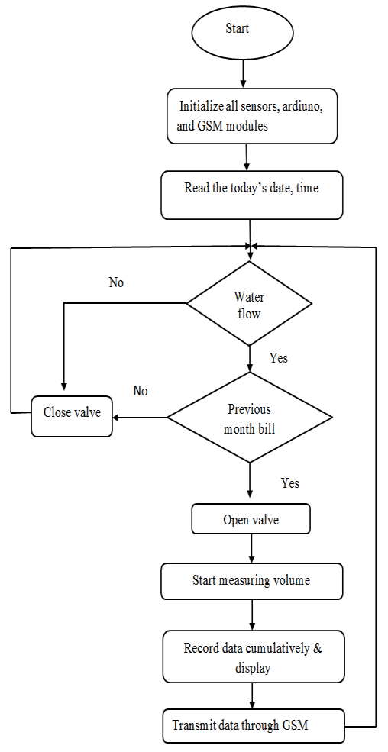

Figure 2: Functional diagram of user side module

**Dam side module**

Dam side module calculates water present in dam and ends data regarding water level present to central office on daily basis. This module containing one ultrasonic sensor to sense the water level and communicates with arduino to process operations such as calculation of water present in dam and then volume data is send to central office using GSM module.

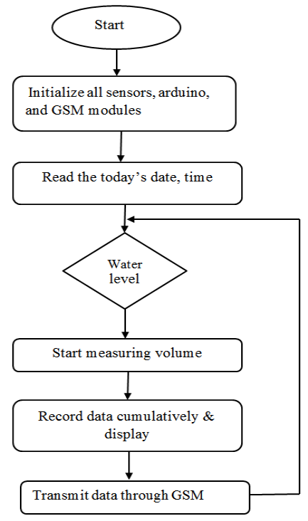

Figure 3: Functional diagram of dam side module

**5. CONCLUSION**

On the basis of analysis and design, the system provides a smart water meter with eco- friendly and energy efficient system. As the smart water meters are digitized and automated, high accuracy is maintained by decreasing human efforts. Water theft can be avoided since there are no mechanical parts that can be subjected to tamper. A flow sensor based water metering system was used for automated billing, eliminating the drawbacks of traditional water metering systems. Further, multiple houses in a building could use separate end nodes with a common gateway connecting to the internet for accurate billing based on individual consumption of houses. An analysis of water usage through various outlets in a house was provided in order to educate residents on cutting down wasteful usage. This paper demonstrates the successful implementation of an internet-based approach to monitor water supply and usage on a real time basis.

**REFERENCES**

[1] Made Saraswati, Endrowednes Kuantama, Pono Mardjoko, ”Design and construction of water level measurement system accessible through SMS”, 2012

[2] Anjana S1, Sahana M N2, Ankith S3, K Natarajan4, K R Shobha5,” An IoT based 6LoWPAN enabled Experiment for Water Management”, IEEE ANTS 2015

[3] <https://www.arduino.cc/en/Main/Products>

[4] http://www.hobbytronics.co.uk/yf-s201-water-flow-meter